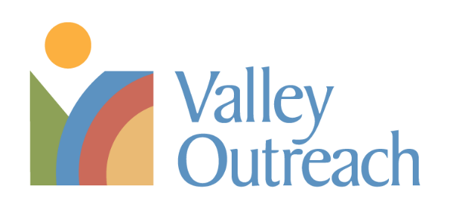
Position: Director of Development
Exempt/Non-Exempt: Exempt
Hours/Week: 40
Annual Salary Range: $85,000 - $90,000
Reports To: CEO

About Valley Outreach:
Everybody needs help sometimes. Valley Outreach offers people a wide range of support – whether they need food, clothing or help navigating resources during challenging times. Our programs include a food shelf, clothing program and client support services. Our volunteers, donors and partners are critical to the success of the mission of Valley Outreach. When we work together, we can help our neighbors find a place of stability.

Position Summary: Bring your leadership talent and creative energy to the fundraising side of a growing basic needs organization. In this new role (yes, new to us, first time!), you will be responsible for building a comprehensive donor engagement/stewardship strategy that expands on our current efforts, integrates our strategic framework priorities, and embeds community-centric fundraising principles.

The Director of Development will be an experienced fundraising professional with documented success in creating and managing a comprehensive development program to provide for the short and long-term needs of the organization.

Valley Outreach offers a competitive benefits package which includes Medical/Dental/Vision insurance as well as Short Term Disability, a Simple IRA, a Flexible Spending Account and an Employee Assistance Program.

Essential Duties & Responsibilities:
- Development Strategy/Plan
  - Work with the CEO and Director of Finance & Administration to develop annual revenue budgets, serving as a point person for ensuring annual revenue is secured.
  - Develop and oversee the implementation of a comprehensive development strategy, establishing fundraising goals for one year, five years and beyond.
  - In partnership with staff responsible for grant writing, further develop approaches for general operating, capital and designated gifts.
  - Evaluate development/fundraising effectiveness using metrics that consider dollars, our strategic framework and community-centric fundraising principles.
- Donor Relations and Outreach
  - Foster a culture of philanthropy throughout the organization that engages donors and volunteers while centering the community.
  - Build relationships with donors to sustain, expand and diversify Valley Outreach’s funding streams.
  - Further a growing major gifts program, including identification, cultivation, solicitation, and stewardship of major individual donors. Donor support goes to both annual operating and program costs and the Vibrant Future Fund (long-term, non-endowed fund).
  - Support completion of Vibrant Future Fund campaign ($1M goal by end of 2023).
  - Management of annual Vibrant fundraising event (350 guests, approximately $200,000 in revenue).
  - Oversee tracking and maintenance of donor information and fundraising activity in the Blackbaud RE NXT database, including oversight of staff responsible for data entry, donor acknowledgment, and gift processing.
  - Maintain and support In-kind giving and fundraising drives in partnership with other staff.
- Leadership and Supervision
  - Provide strategic leadership and supervision to the Development Team with clearly articulated goals, objectives and fundraising targets.
  - Management of 1, full-time staff with potential to grow the team.

What you bring:
- Curiosity, flexibility and a drive to thoughtfully and creatively problem-solve in a changing environment.
- A strong record of personal achievement in cultivating donors, building strong relationships, and raising major gifts is essential.
- A minimum of 5-10 years of experience in fundraising for a nonprofit organization preferred.
- Extensive knowledge of fundraising strategies and principles, including community-centric approaches.
- Ability to articulate thoughts and express ideas effectively using oral, written and non-verbal communication skills (to inform, instruct, and persuade), to multiple audiences, as well as to listen for meaning and understanding.
- Capacity to manage colleagues in ways that build strong, productive, collaborative working relationships.
- Commitment to racial equity and social justice and willingness to be actively engaged in ongoing equity work.
- Strong understanding of working with individuals of differing ages, races, and socio-economic backgrounds.
- Ability to safely and successfully perform the essential job functions consistent with the ADA and other federal, state and local standards, including meeting qualitative and/or quantitative productivity standards.

To apply for this position:

- Forward your resume and cover letter to jobs@valleyoutreachmn.org and place Director of Development in the subject line.
- The process will include:
- Review of information from all interested parties. Be sure to give us your phone number and email so we are able to contact you.
- A phone screening conversation will be set up with those candidates who most closely meet the requirements of the position.
- Several candidates will be invited to an in-person conversation regarding the position.
- If needed, a second in-person conversation will be scheduled.

